Creating Repo for course JSReview-23
JS used for
DOM Manipulation
Event Handling
Asynchronous Requests
Animation and Effects
Data Manipulating (Map filter reduce)
Storing data on clinent with cookies and local storage
Single Page Applications (SPA) possible with plain vanila JS or can use something like react
Consume or create APIs
Creating API and Web services like node express Deno ( Deno is a runtime for JavaScript, TypeScript, and WebAssembly that is based on the V8 JavaScript engine and the Rust programming language. Deno was co-created by Ryan Dahl, who also created Node.js. )
React native can make mobile apps
2:9 Using the console – the console is an object
Function +f12 opens console
Use the vs code snipit clg
Console.table() is kind of cool
Cool way to add styles
const styles = "padding:100px;background-color:white;color:red";
console.log("%cHello world", styles);
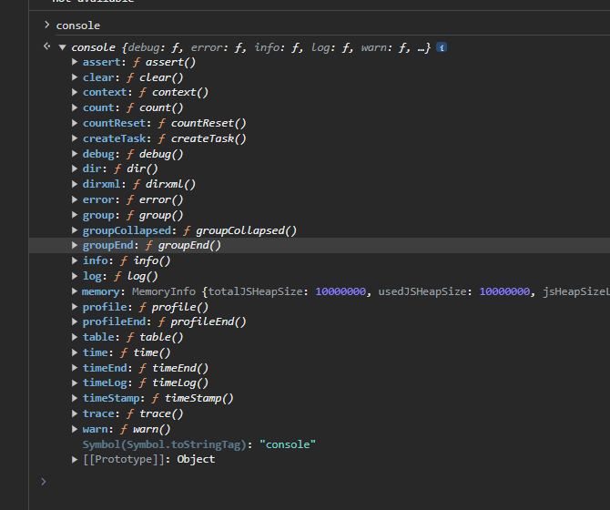

Commenting out multiple lines with there own // -Got to the beginning or end of lines of code and press shift then drag up or down, then CNTL / and each line will be commented out individually
Find a word and then CNTL Shift L – will highlight every word
CTRL B in vs code toggles the file sidebar
variables and constants
can make an array or object a const and still change the values within it
Data types –
Primitive Data Types vs Reference Types (Objects)
Primitive data types , Strings, Numbers ,Boolean ,Null, undefined , symbol
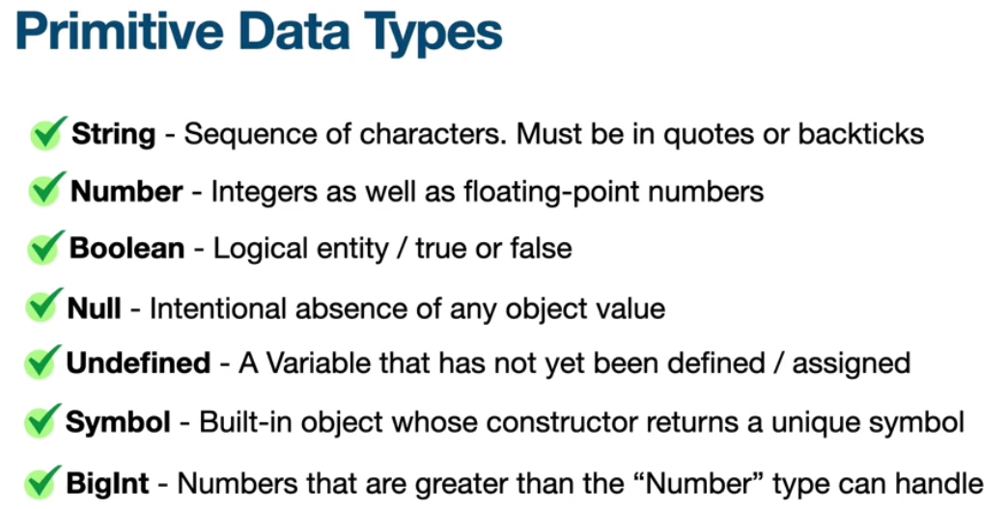
Reference Types – objects
Reference types or objects are a non primitive value and when assigned to a variable, the variable is given a reference to that value.
Object literals, arrays and functions are all reference types
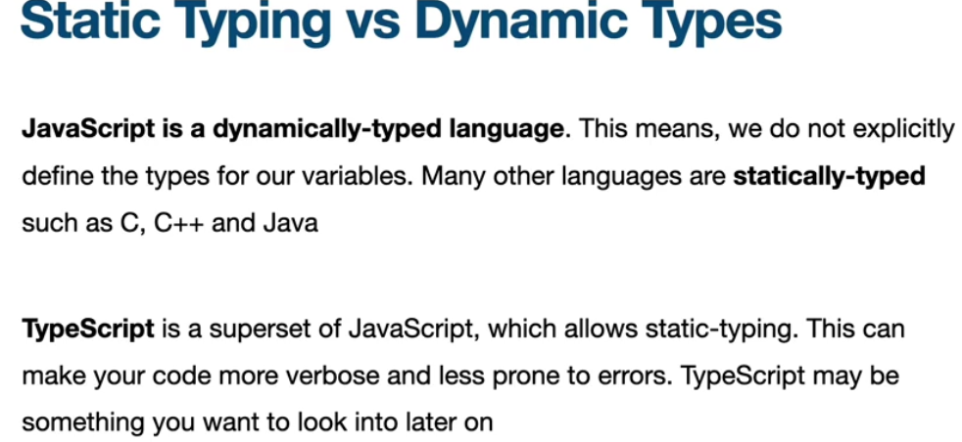
Stack vs Heap – different areas of memory
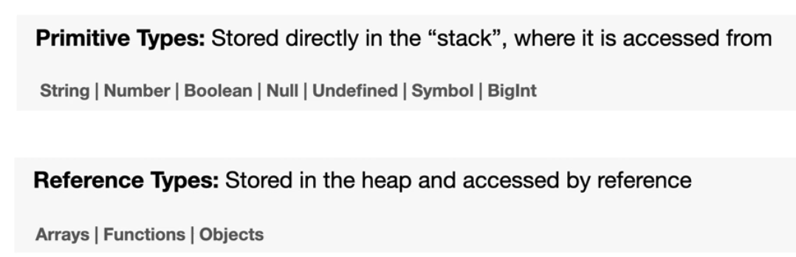
Point to same location on heap
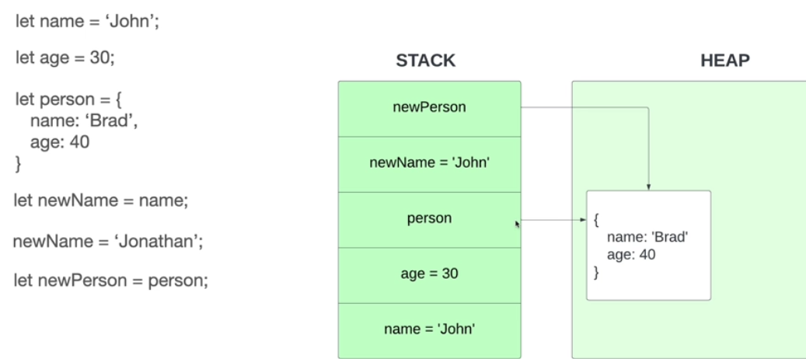
14 Type conversion aka type casting
15 Operators or symbols
Arithmetic, concatenation, exponential, increment, decrement, assignment, comparison,
16 – Type Coercion Type Coercion refers to the process of automatic or implicit conversion of values from one data type to another. This includes conversion from Number to String, String to Number, Boolean to Number etc. when different types of operators are applied to the values
17- Working with strings -
// Creating a "string object" (JS does this automatically when using a property or method on a primitive string)
const s = new String("Hello World"); // type of object
const t = "Hello World"; // type sting
19 Working with numbers
Restart here
https://www.udemy.com/course/modern-javascript-from-the-beginning/learn/lecture/37191220#overview

Start of Arrays and objects https://www.udemy.com/course/modern-javascript-from-the-beginning/learn/lecture/37191250#overview

